./

Learning Report – MBSE

Course Code: <CODE>



Version Number:

Team Members :

Team No:

Module: Model Based System Engineering

|  |  |  |  |  |  |
| --- | --- | --- | --- | --- | --- |
| **Ps No.** | **Release Date** | **Prepared. By** | **Reviewed By** | **Approved By** | **Remarks/Revision Details** |
| 99003740 | 19-03-21 | Rajendra Hanagodi |  |  |  |

**Document History**

Contents

Team Work 3

**Activity 1** – Understanding Different MBSE Workflows Based on Business Domain 4

**Activity 2** – Modelling – Collective Learning (use any UML online tools: eg:- draw.io) 4

**Activity 3** – Explore the below resources and share learning and critical comments on the same 4

**Activity 4** – Complete Matlab Onramp 5

**Activity 5** – Complete Simulink Onramp 5

**INTERIOR LIGHTS**

1. **INTRODUCTION**

Most cars have at least one "dome light" (or "courtesy light") located in or near the ceiling of the passenger compartment, to provide illumination by which to fasten seatbelts and enter or exit the car. These often have an option to switch on when the front (or any) passenger doors are opened. Many vehicles have expanded this feature, causing the overhead interior light to remain on after all doors are closed, allowing passengers to fasten seat belts with added illumination. The extended lighting cycle usually ends when the vehicle's ignition has begun, or a gradual reduction in light emitted after a couple of minutes if the car isn't started, called "theater" lighting. Interior lighting has been added on some vehicles at the bottom edge of the dashboard, which illuminates the floor for front passengers, or underneath the front seats at the rear, to illuminate the floor for rear seat passengers. This type of convenience lighting approach is also sometimes used to illuminate interior or exterior door handles, exterior step running boards, or electric window switches.

Most instruments and controls on a dashboard in modern vehicles are illuminated when the headlamps are turned on, and the intensity of light can be adjusted by the driver for comfort. Saad automobiles, for example, have an aircraft-style "night panel" function which shuts off all interior illumination save for the speedometer (unless attention is called to a critical situation on another gauge) to improve the driver's night vision.

1. **FEATURES: -**
2. Interior lights

**REQUIREMENT:**

High Level Requirement (HLR):

* Interior lights like dome and reading lights become on/off and brightness of instrumental panel become brighten.

Low Level Requirement (LLR):

* Dashboard brightness increase/decrease by rotary button.
* Reading lamps are ON when Doors are open or by manual switch.
* Dome lamps are ON when Doors are open or by manual switch.

**SWOT Analysis:**

|  |  |
| --- | --- |
| **Strength**   * Innovation and user friendly. * Durable and long lasting. * Easily available in market. * Good referral relationships with architects, complementary vendors and local realtors | **Weakness**   * Not established in a market where a variety of interior design options exist. * Challenges of the seasonality of the business. * Competitors can offer similar products quickly |
| **Opportunities**   * Interior Lights can be used in any vehicles like in bus, trucks, train etc. * Interior lights can be used in home appliances to pleasing environment. | **Threat**   * Rising prices of materials and services * Designers being contracted up from the city * Changes in regulations can impact the business |

**RESEARCH:**

**GMC-SIERRA 2020**

**Intake:**

* This feature controls the brightness instrument panel lights. The instrument panel illumination control is next to the exterior lamp control. Press D + to brighten or D − to dim the lights.

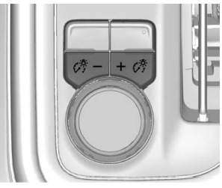

* The dome lamp controls are in the overhead console. The dome lamps will come on when doors are opened. ON/OFF: Press to turn the dome lamps on manually. Press again to turn the dome lamps off.

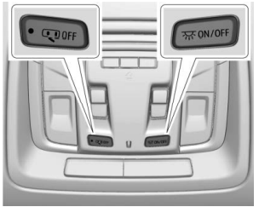

* There are reading lamps on the overhead console and over the rear seats. These lamps come on when any door is opened. Press to turn the dome lamps on manually. Press again to turn the dome lamps off.

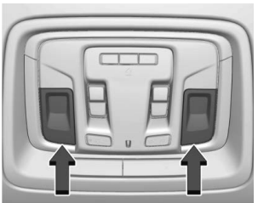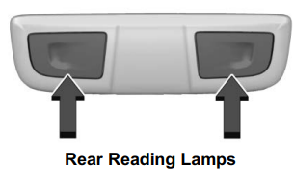

**Inputs:**

* **User inputs:**

1. **Rotor switch: A** **rotary switch** is a switch operated by rotation.

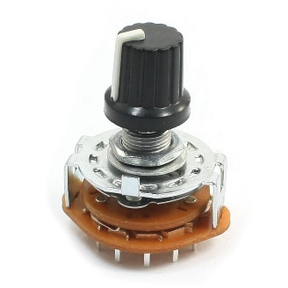

1. **Push to on/off switch:**

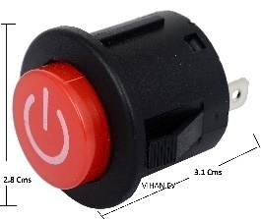

* **Sensor inputs:**

1. **Push Buttons:** A **push-button** is a simple switch mechanism to control some aspect of a machine or a process. An automatic mechanism (i.e. a spring) returns the switch to its default position immediately afterwards, restoring the initial circuit condition.

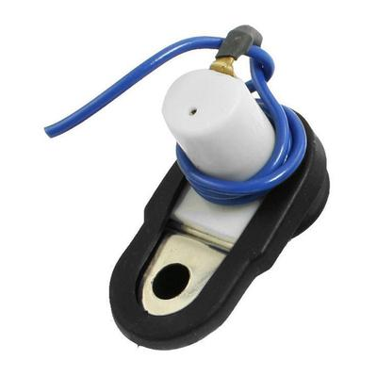

|  |  |  |  |
| --- | --- | --- | --- |
| **Technical Specifications** | **Push Buttons** | **Rotor Switch** | **Push to on/off switch** |
| Voltage | 24v DC | 28v DC | 24v DC |
| Power Rating |  |  |  |
| Current Rating | MAX 50mA | 350mA | 50mA |
| Insulation Resistance | 100Mohm at 100v |  | 100Mohm at 100v |
| Operating Force | 2.55±0.69 N |  |  |
| Temperature range | -25 to +55°C | -25 to +55°C | -25 to+55°C |
| Angle of throw | - | 30degree | **-** |

**Outputs:**

* Dome lights:

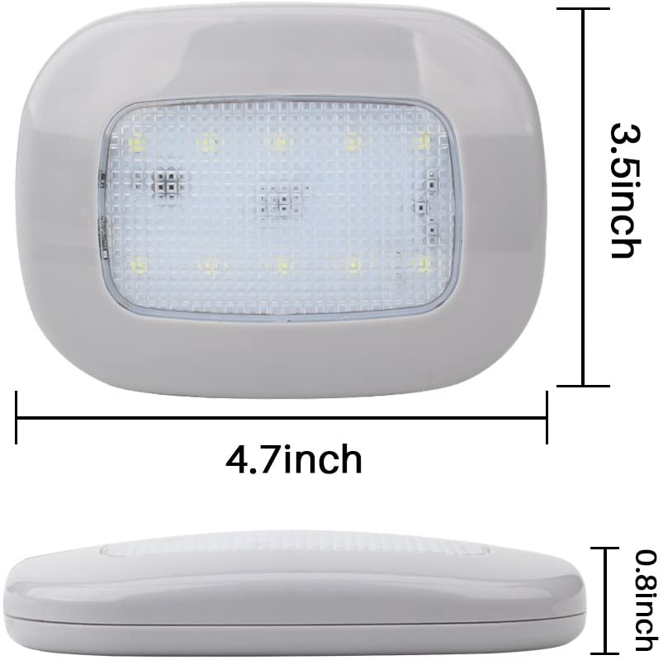

* Reading lights:

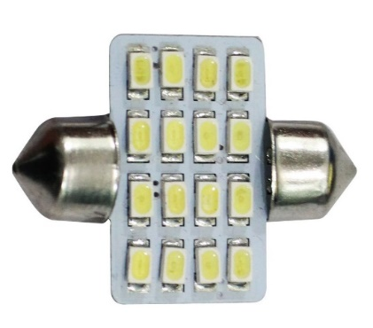

* LED Lights:

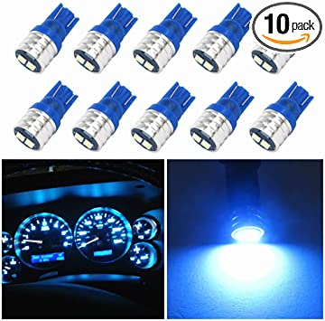

|  |  |  |  |
| --- | --- | --- | --- |
| **Technical Specifications** | **Dome lamp** | **Reading lamp** | **LED** |
| Voltage | 12v DC | 12v DC | 12vDC |
| Current | 0.2A | 0.2A | - |
| Power | 2.5W | 2.5W | 1W |
| Temperature range | -40c to 65c | -40c to 65c | - |

**ALGORITHM:**

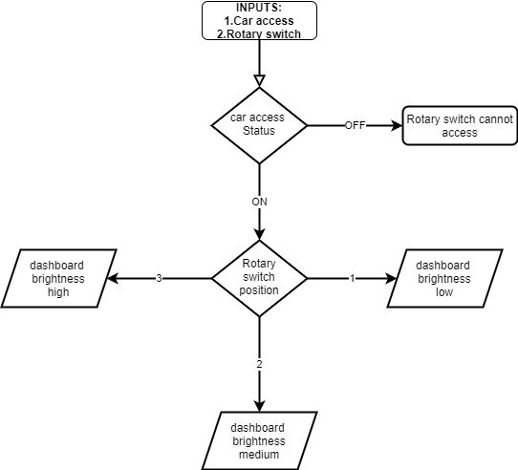

Figure 1.Instrument panel Brightness flowchart

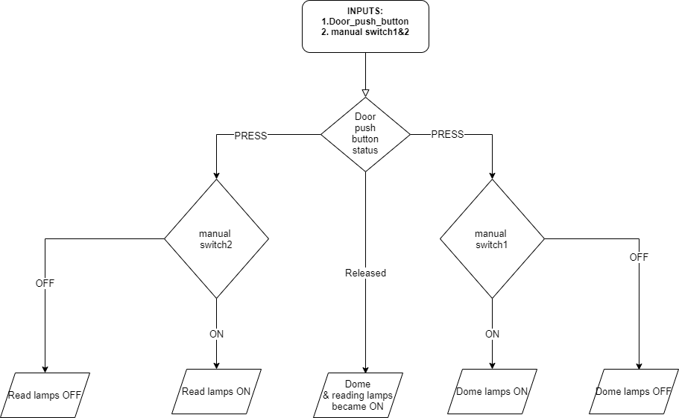

Figure 2.Dome and Reading Lights flowchart

**Interior lights Design & Implementation:**

**High level Design:**

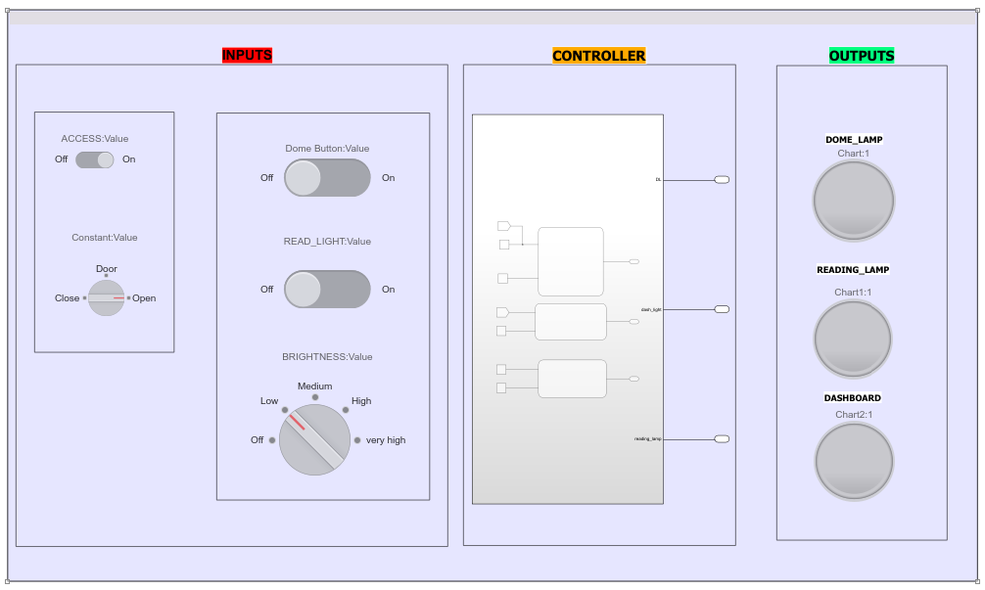

**Low Level Design:**

Doom lamp Design:

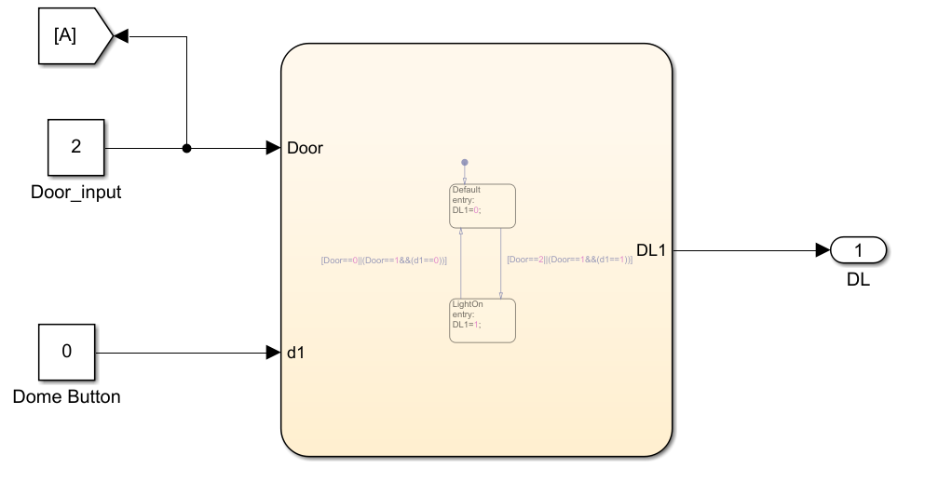

Reading lamp Design:

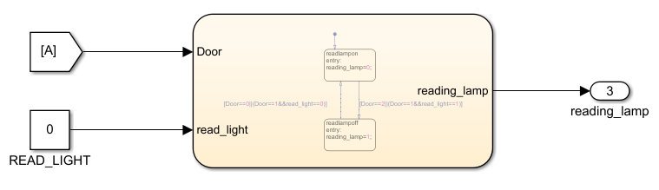

Dashboard Brightness Design:

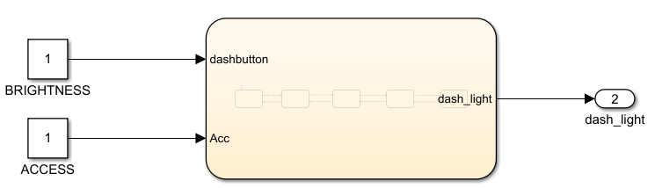

**TEST PLAN**

|  |  |  |  |  |  |
| --- | --- | --- | --- | --- | --- |
| **Test id** | **Description** | **Expected i/p** | **Expected o/p** | **Actual o/p** | **Type of test** |
| LR_1 | Dome Lamp is ON whenever door is open irrespective of manual inputs | Any one door open | Dome Lamp should ON | Dome Lamp ON | Requirement base |
| LR_2 | Reading Lamp is ON whenever door is open irrespective of manual inputs | Any one door open | Reading Lamp should ON | Reading Lamp ON | Requirement base |
| LR_3 | Dome Lamp is ON door is closed and manual switch is ON | Door should be closed and dome manual switch to ON | Dome Lamp should ON | Dome Lamp ON | Requirement base |
| LR_4 | Reading Lamp is ON door is closed and manual switch is ON | Door should be closed and reading manual switch to ON | Reading Lamp should ON | Reading Lamp ON | Requirement base |
| LR_5 | Dashboard LED is brightening according to rotary switch | Car Access enable and rotary switch position 1 | Low brightness | Low brightness | MCDC BASE |
| HR_1 | Interior lights like dome and reading lights become on and brightness of instrumental panel become brighten. | Dome switch, reading switch to ON and rotary switch | Dome Lamp and Reading Lamp should ON and brightness increases/decreases | Dome Lamp and Reading Lamp should ON and brightness increases/decreases |  |